Exp No:09
Exp Name: Implementation of Trapezoidal Method in Numerical Integration
Theory:
Numerical Integration is a powerful technique used to estimate the value of a definite integral when we can't solve it analytically or when we only have a limited set of data points. One of the most frequently used methods for this task is the Trapezoidal Rule. The fundamental idea behind the trapezoidal method is to approximate the area under the curve of a function, f(x), over a specific interval [a, b]. Instead of using simple rectangles, as is common in basic Riemann sums, this method employs trapezoids, which usually fit the curve more closely.
To do this, we first divide the total integration interval [a, b] into n smaller, equal-width sections, called subintervals. The width of each subinterval is designated by h, calculated as: $h= \frac{b-a}{n}$For every pair of adjacent points, (x_{i}, f(x_{i})) and (x_{i+1}, f(x_{i+1})), a trapezoid is formed. The area of this individual trapezoid is determined by the formula:
$$Area= \frac{h}{2} \left[f\left(x_{i}\right)+f(x_{i+1})\right]$$
The total approximate value of the integral is then found by simply summing the areas of all these individual trapezoids across the entire interval. The General Formula:
$$\int_{a}^{b}{f\left(x\right)dx≈ \frac{h}{2}\left[f\left(x_{0}\right)+2\left(f\left(x_{1}\right)+f\left(x_{2}\right)+…+f\left(x_{n-1}\right)\right)+f\left(x_{n}\right)\right]}$$
The Trapezoidal Method is favored due to its intuitive nature and ease of application, often providing a respectable level of accuracy for many functions. However, when dealing with functions that exhibit significant curvature or abrupt changes, the precision of the approximation typically diminishes. In these specific instances, obtaining a satisfactory level of precision necessitates the use of a significantly greater number of subintervals (n).
Program:
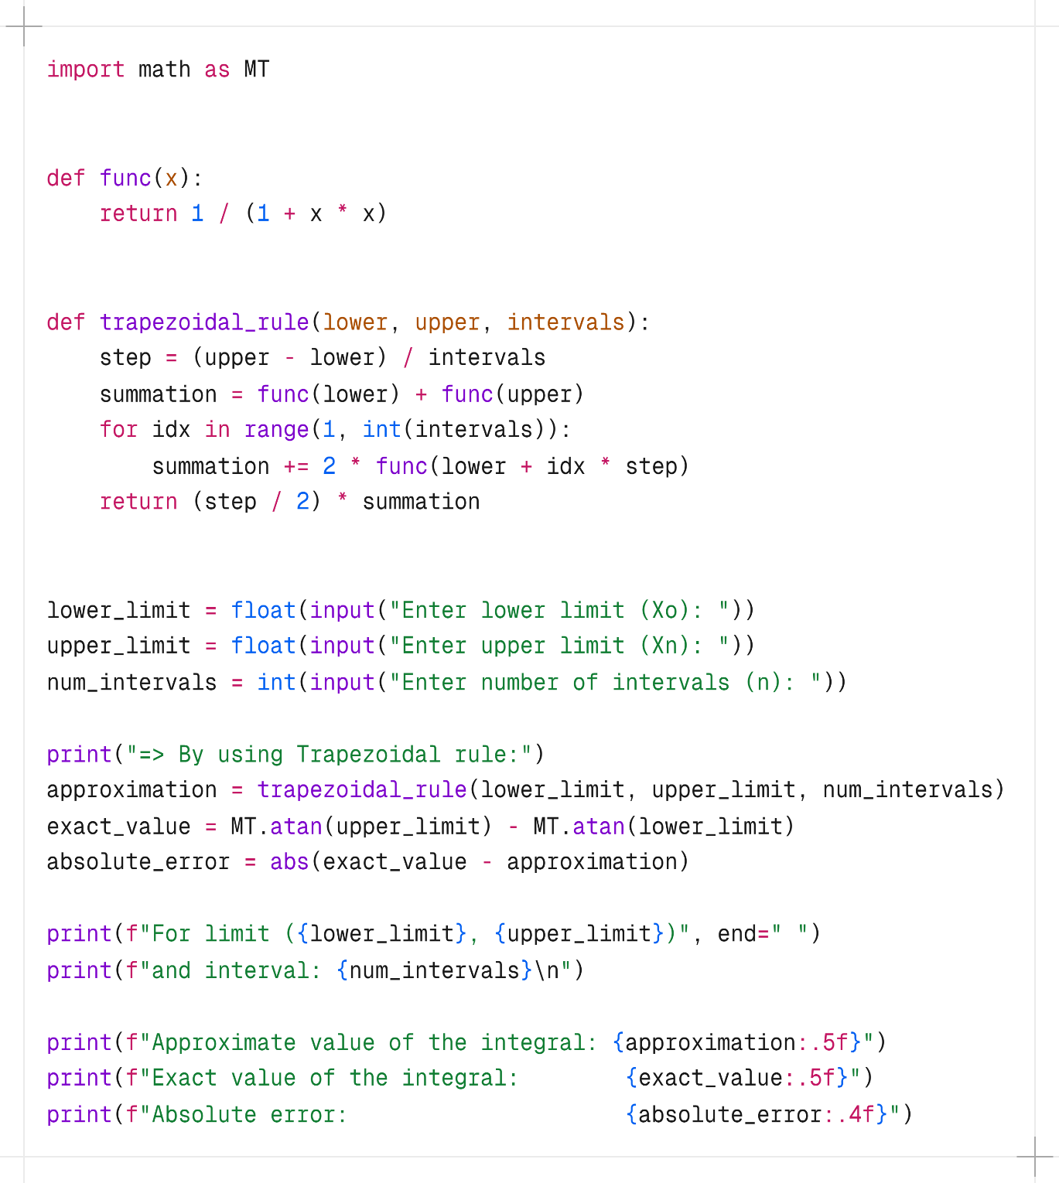
Output:
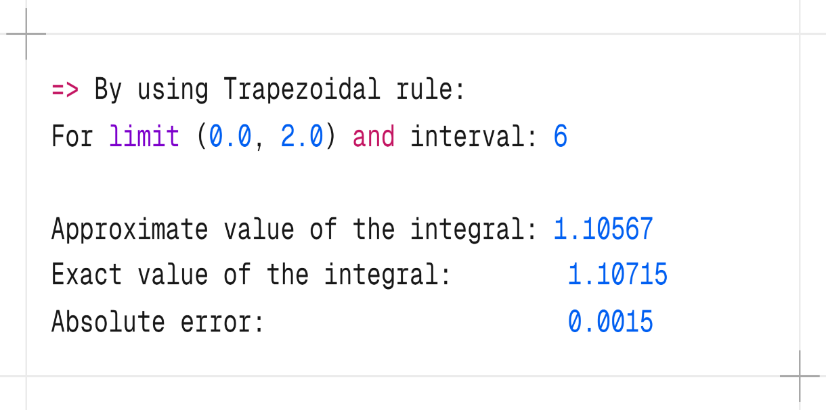

Discussion & Conclusion:
In this experiment, the Trapezoidal Method was applied to approximate the definite integral of a given function by dividing the interval into a number of equal subintervals and estimating the area using trapezoids. The result obtained from the numerical method was compared with the exact analytical value of the integral. The comparison clearly showed that the approximation improves as the number of intervals increases, because smaller subintervals provide a closer representation of the actual curve. Although the trapezoidal rule is simple and easy to implement, its accuracy is limited because it approximates the function using straight-line segments. For functions that curve sharply, the error becomes noticeable unless a large number of intervals is used. However, for smooth and slowly varying functions, the method performs reasonably well. The trapezoidal method offers a practical and straightforward technique for numerical integration, especially when analytical solutions are complicated or unavailable. While it is not the most precise method, increasing the number of subintervals significantly reduces error. This experiment demonstrates the usefulness of numerical approaches for estimating integrals and highlights the trade-off between computational effort and accuracy.

Experiment No.: 10
Experiment Name: Implementation of Simpsons Method in Numerical Integration
Theory
Simpson's Method is a more accurate way to estimate definite integrals compared to the simpler Trapezoidal Rule. The key difference is how Simpson's method "sees" the curve. While the Trapezoidal Rule connects points with straight lines, Simpson's Rule fits a smooth curve (a parabola, or quadratic function) over every two sections. This parabolic fit is much better at mimicking the true shape and curvature of the function, leading to a far more precise estimate of the area underneath it. The Simpson's 1/3 Rule
method requires to divide the total integration interval [a, b] into an even number (n) of equally sized subintervals. The width of each is still $h= \frac{b-a}{n}$. It applies alternating weights of 4 and 2 to the intermediate function values, capturing the curvature of the function more accurately. The formula for Simpson’s 1/3 rule is:
$\int_{a}^{b}{f\left(x\right)dx≈ \frac{h}{3}\left[f\left(x_{0}\right)+4\left(f\left(x_{1}\right)+f\left(x_{3}\right)+…+f\left(x_{n-1}\right)\right)+2\left(f\left(x_{2}\right)+f\left(x_{4}\right)+…+f\left(x_{n-2}\right)\right)+f\left(x_{n}\right)\right]}$
To achieve its high accuracy, Simpson's 1/3 Rule uses a clever system of alternating weights on the function values:
- Weights of 4: Applied to the function values at the odd-numbered positions (e.g. : f(x₁​), f(x₃​), …, f(x_{n-1})).
- Weights of 2: Applied to the function values at the even-numbered positions (e.g., f(x₂​), f(x₄​), …, f(x_{n-2})), excluding the very last point.
Simpson’s method is significantly more accurate than the trapezoidal method when the function is smooth, because parabolic fitting captures curvature better than straight-line approximations. For many functions, Simpson’s rule provides results extremely close to the true integral even with a modest number of intervals. The only requirement is that the number of intervals must be even.
Program:
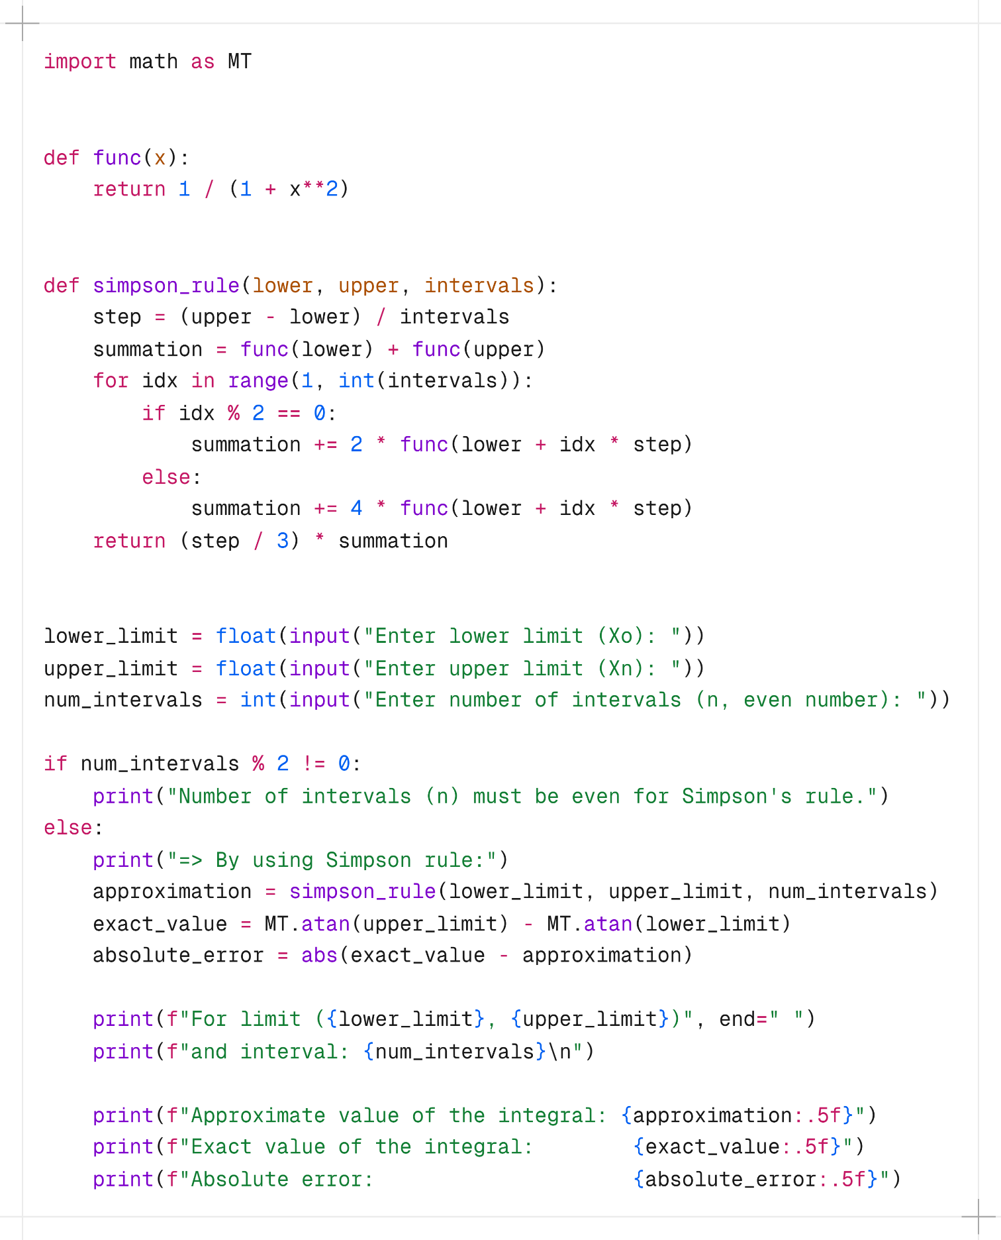

Output:
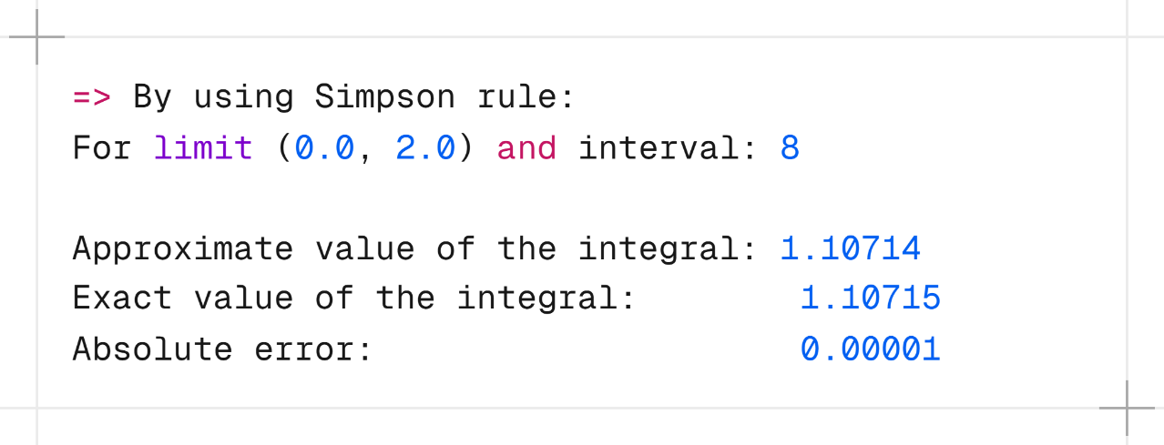

Discussion & Conclusion:
This experiment used Simpson’s 1/3 Rule to approximate the value of a definite integral numerically. Unlike the trapezoidal method, Simpson’s method fits parabolic curves between intervals instead of straight lines, which makes the approximation much closer to the true value. The results showed that Simpson’s rule provides a significantly lower error compared to the trapezoidal method using the same number of intervals. The requirement that the number of intervals must be even ensures consistent application of the 4–2 weighting strategy. Because the method captures the curvature of the function effectively, it often produces results that are almost identical to the analytical solution even with fewer subintervals. Simpson’s method is more accurate and efficient than the trapezoidal method due to its use of quadratic interpolation. It delivers high precision with relatively fewer computations, making it one of the most preferred numerical integration techniques for smooth functions. This experiment verifies that Simpson’s rule is a superior choice for reliable approximation of definite integrals in practical situations.

